Key Point Report on UPB LSP 1 Training, CATALYST LSP Training (Language for Specific Purposes), December 3rd - December 16th 2017, University of Politehnica Bucharest (UPB), Romania
Training location: University of Politehnica Bucharest, Central Library, 2nd floor,
Room 2.3

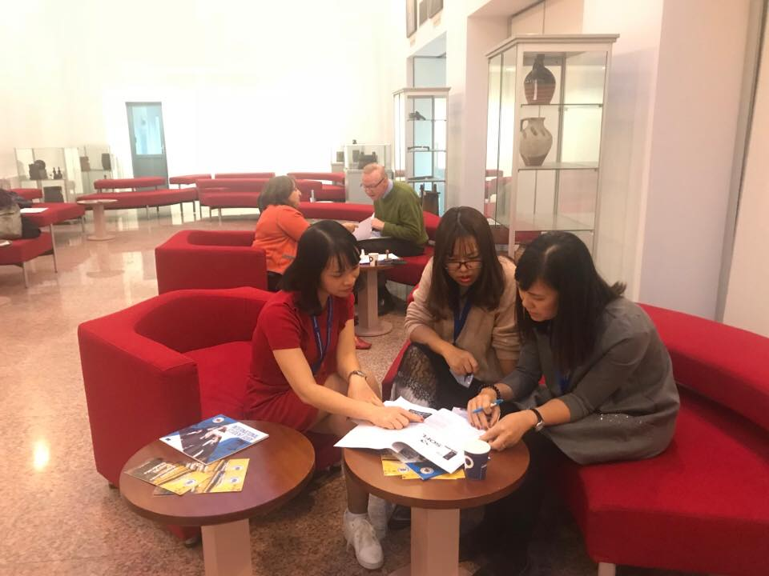
Summary
This training represented the first Language for Specific Purposes 1 training for vocational education in Vietnam and Laos. This was conducted according to the specialist skills of the individual EU partners and in some cases involved joint cooperation.
The training was conducted over a 10 day period. We found the facilities and organisation of the event to be very competent and participation of both groups was consistently good with strong motivation. Detailed minutes were kept by selected B1+ PC colleagues as a statement of record and as a consolidation effort.
The attendees included:
1. Host:
- University of Politehnica of Bucharest: 3 members
+ Lazarou Elisabeth
+ Trifan Elena Laura
+ Micoroiu Cornelia
2. Guests:
Delegations from
- Edge Hill University (EHU), UK: 2 members
+ David Allan
+ Clare Woolhouse
- Ho Chi Minh University of Technology and Education: 3 members
+ Nguyen Vu Lan
+ Nguyen Van Tuan
+ Duong Thi Kim Oanh
- Ho Chi Minh University of Technology (HUTECH): 3 members
+ Nguyen Lan Huong
+ Nguyen Thi Kieu Thu
+ Le Dang Tho
- Hanoi University of Science and Technology (HUST)
+ Pham Hoai Anh
+ Nguyen My Binh
+ Le Nu Cam Le
- University of Languages and International Studies – Vietnam National University, Hanoi (ULIS-VNU)
+ Vu Hai Ha
+ Nguyen Thuy Phuong Lan
+ Nguyen Thi Thanh Van
- Hung Yen University of Technology Education (UTEHY): 3 members
+ Nguyen Huu Hop
+ Vu Hong Son
+ Nguyen Van Hau
- Vinh University of Technology Education (VUTED): 3 members
+ Phan Thi Tam
+ Vo An Hai
+ Nguyen Thi Hong Thom
- National University of Laos (NUoL): 3 members
+ Khammounty Bounseng
+ Sounvoravong Xayyachack
+ Bounphasouk Phannavong
- University of Health Sciences (UHS)
+ Phrasisombath Ketkesone
+ Sounthavong Outhip
- TU Dresden (TUD)
+ Cullen, Gerard
+ Foley, Sandra
- The Pyramid Group (TPG)
+ Nguyen, Quynh
- Limerick Institute of Technology (LIT)
+ Kirby, Padraig
Day One necessarily included a full review of all financial matters and administration issues.
The following days focused on training after an introduction into project goals and objectives.
The following modules for all PC universities in Vietnam and Laos were covered in detail and all content was transferred to partners and additionally uploaded on GoogleDrive:

LSP Module Training Contents Part 1 Bucharest

Nr. | Short Description | Responsible EU Training Partner
1 | Communicative Approach versus Traditional Approach in the classroom and use of oral skills for presenting, lecturing, public speaking. Approach on Multiplication Factor Trainer for effective multiplicator at home and in domestic institutions. | EHU/TUD
2 | ICT/Blended/E-Learning based vocational teaching and learning approaches | EHU
3 | Innovation methodology in vocational teaching and learning (including the use of the internet/library/media centre for lesson development and implementation). | LIT
7 | Teaching for Diversity in vocational education for individuals with special needs and including a focus on intercultural awareness. Here teaching strategies will be designed to be fully inclusive, incorporating strong differentiation and the necessity to address special educational needs and disabilities (SEND) at vocational level. | EHU/LIT
8 | Module 8 Professional Development & Reflection | EHU
9 | Quality Assurance and Planning in vocational education (including observation, self-assessment techniques, using ECTS and EU Tuning Frameworks in modular creation). | TUD/TPG

Supplementary Module – TUD/LIT/EHU/TPG

Module 10: ONGOING
ESP Pathway Program Module - English for Specific Purposes Training (terminology, soft skills, key writing skills) package for PCs based on in depth need analysis will be developed and will be integrated into official university curricula for weaker staff and domestic/international students as a Pathway Program.

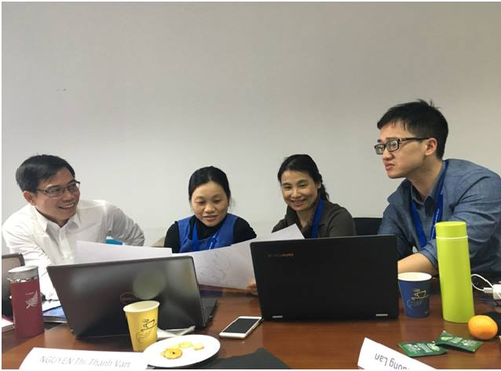

Conclusion
The CBHE CATALYST project focuses on developing university vocational teachers teaching methodologies.
In general the level of English was satisfactory which allowed participants to understand and communicate effectively in the tuition process. We again outlined and delegated online self-learning materials to the appropriate CEFR level groups. Additionally we gave all PC universities the specific CATALYST A1-A2 Grammar Script and Key (developed by TPG and TU Dresden) which participants can continue to use on a class or self-study basis. Furthermore Soft Skills materials were distributed to the second B1 group specifically on presentation and public speaking skills. We underlined the importance of the Module 10 ESP Pathway Program Module - English for Specific Purposes Training (terminology, soft skills, key writing skills) package as an ongoing module at ALL PC institutions which would later need to be integrated into official university curricula for weaker staff and domestic/international students as a sustainable Pathway Program. However, some still need substantial further support in order for appropriate participation in the Catalyst project and to fulfil the specific and wider key project objectives.
As this type of EU CBHE project is very new to the colleagues from Vietnam and Laos colleagues from TUD and TPG later compiled an easy-view overview orientation of all deliverables whilst pointing out that the project actually had started five months behind schedule:

CATALYST

OVERVIEW OF DELIVERABLES

Deliverable N° | Title | Delivery Date
Work Package 1 Preparation (TUD)
1.1 | Start Off Meeting  QA and control guidance  Report of processes and agreements  TUD+ all | 15-10-2016
1.2 | Initiation Development of Online Platform  Development of Online Platform with QA Guidelines for population to site starts immediately after Start Off meeting and Online Platform Needs.  TPG+PCs | 30-11-2016
1.3 | Preparation of EU QA English for Specific Purposes Training and Pedagogical Training Packages  TUD | 30-01-17
1.4 | Preparation of and negotiating PC Division of Core Curricula Tuning/ECTS  TUD + all | 15-06-17
Work Package 2 Development (TPG)
2.1 | EU Training of QA English for Specific Purposes Training and Pedagogical Training for PCs  TUD+ | 15-02-2017
2.2 | PC Home Multiplier Factor Training Inputs of ESP and general Pedagogical Training  PCs | 31-03-2017
2.3 | First Piloting of Core Curricula  PCs | 31-02-2018
2.4 | Second Piloting of Core Curricula  PCs | 19-10-2018
2.5 | Third Piloting of Core Curricula  PCs | 30-02-2019
2.6 | Home Multiplier Staff Training of Core Curricula  PCs with Reporting to steering group meetings | 14.10.2019
Work Package 3 Quality Plan (EHU)
3.1 | QA Evaluation and Core Curricula Modules online provision. Module piloting assignment  EU+ PCs | 25-09-2017
3.2 | EU & PC QA Evaluation of 1st Piloting  EU review based on questionnaire feedback  Module+Seminar teaching load distribution for 2nd piloting fixed  EHU+ all | 22-10-2017
3.3 | 1st Round of QA monitoring visits by EU partners with Master-Classes Inputs  TUD + EU partner observations  QA Observation Reports and distribution to PCs  TUD + all | 26-11-2017
3.4 | EU & PC QA Evaluation of 2nd Piloting  EU review by observing partners  Module+Seminar teaching load distribution for 3rd piloting fixed  EHU+ all | 30-02-2018
3.5 | 2nd Round of QA monitoring visits and masterclass inputs by EU partners  TUD+ all | 26-10-2018
3.6 | EU & PC QA Evaluation of 3rd Piloting  EHU + all | 30-01-2019
Work Package 4 Dissemination and Exploitation (LIT)
4.1 | Ongoing Population of Online Platform  LIT+TUD + all | 01-10-2017
4.2 | National PC Project Status Awareness Day Conference Year 1  PCs | 01-10-2017
4.3 | Ongoing Population of Online Platform in Year 2  TUD+ all | 01-10-2018
4.4 | National PC Project Status Awareness Day Conference Year 2  PC countries | 01-10-2018
4.5 | Ongoing Population of Online Platform in Year 3 for piloting 3  TUD + all | 01.10.2019
4.6 | Sustainablility –Official Accreditation Process for Core Curricula including Inter-university Module Recognition Agreements  EU+ PCs | 30-07-2019
4.7 | Final Project Conference  In LAOS  all | 20-09-2019
Work Package 5 Management (UPB)
5.1 | Regular Steering Group management meetings to review objectives, progress and ensure QA compliance  UPB+ all | 12-10-2019
5.2 | Year 1 project Planning and Co-ordination with Annual Report  EU+ all | 30-09-2017
5.3 | Interim Project Planning and Co-ordination QA Meeting at LIT | 12-06-2018
5.4 | Regular Steering Group management meetings to review objectives, progress and ensure QA compliance in Year 2  EU + all | 30-09-2018
5.5 | Year 2 project Planning and Co-ordination with Annual Report  EU+ all | 30-09-2018
5.6 | Regular Steering Group management meetings to review objectives, progress and ensure QA compliance in Year 3  EU+ all | 30-09-2019
5.7 | 2nd Interim Project Planning and Co-ordination QA Meeting at EHU, presentation of outcomes and outputs  EU+ | 03-04-2018
5.8 | Management Preparation for Final Conference EU steering gp + PC steering+ Lead Ptnr  EU+ | 30.07.2019
5.9 | Year 3 project Planning and Co-ordination with delivery of Final Project Co-ordination Reports EU+ | 30-09-2019

Gender balance from Vietnam was good while the Laos colleagues need to rectify the situation at the LSP 2 and subsequent trainings. Laos colleagues were informed of this and they noted EACEA interest in achieving such a balance as best practice.
On the last day all the training was reviewed and attendees were asked to review same and clarify any outstanding issues.
Provisional plans were made on dates of First to Third Piloting and the procedural processes. Delegates were asked to submit minutes of meetings and to undertake a full review of all training materials.
All visa invitation processes for LSP 2 in Dresden (March 2018) were initiated.
Attendees were asked to process their travel paperwork in accordance with EACEA project guidelines.

Project Publicity Team for Erasmus+ EU CBHE CATALYST (Communicative Approaches in University Vocational Teaching Methodology Focusing on Improving Educational Yield and Sustainability)
CONTACT-Project Publicity Officer (VIETNAM & LAOTIAN UNIVERSITIES)
Name of university | Contact/Project Publicity Person | Position  at University | Email | Skype | Contact Telephone Number
UTEHY (University of Technology and Education) | NGUYEN Van Hau | Head of Software Engineering Department | nvhau66@gmail.com | nvhau66 | +84 943651135
HCMUTE  (Ho Chi Minh City University of Technology and Education) | NGUYEN Vu Lan | Vice Dean of International Affairs Office | lannv@hcmute.edu.vn | Nguyenvulan81 | +84 913522142
ULIS, VNU  (University of Languages and International Studies, Viet Nam National University) | PHUNG Thi Kim Dung | Vice Dean of Facullty of  English Language Teacher Education | kimdungspta@gmail.com | Kimdzung77 | +84 943032992
HUTECH  (Hochiminh City University of Technology) | PHAM Thi Hai Quynh | Vice Director – Institute of International Education | pth.quynh@hutech.edu.vn | phamhai.quynh | +84 918300109
HUST  (Hanoi University of Science and Technology) | PHAM Hoai Anh | Lecturer, Vice Head of Department of Professional English | phamhoaianhbk@gmail.com;  anh.phamhoai@hust.edu.vn | phoaianh | +84.168.4460.764
VUTED  (Vinh University of Technology Education) | TRAN Thi Thuy | Administrative official  Center for Training and Professional Development, VUTED | tranthithuy0911@gmail.com | tuankiet2604 | +84.983 313 424
University of Health Sciences (UHS-Laos) | Ketkesone Phrasisombath | Director, Academic Affairs Division | ketkesonp@gmail.com  ketkesone.phrasisombath@yahoo.com | Ketkesone.Phrasisombath | +856 20 2265 14192
National University of Laos | Bounseng Khammounty | Head of Department | bounseng@fe-nuol.edu.la | Bounseng.Khammounty | +8562055720011
National University of Laos | Xayyachack Sounvoravong | Deputy Head of Office of the Faculty of Engineering | Xayyachack@nuol.edu.la | Xayyachack Sounvoravong | +8562022499879

Note: At the basic level the Project Publicity Officer role means being responsible for putting up and actively maintaining the project link on the home university website with full progress information on deliverables, dissemination and sustainability efforts, collecting all reports, photos etc, plus setting up and sending info to the project Twitter and Facebook accounts.

The website needs were reviewed and Publicity Officers for each university were established (as above) - each publicity officer is responsible for the home university project link and updates. HCMUTE and HUTECH agreed to set up Facebook, Twitter and Google box and inform everybody. We wish to thank all parties involved in making the training a successful one.
Gerard Cullen/Paul East
12 January 2018.

