Key Point Report on LSP 2 Training, CATALYST Training (Language for Specific Purposes), March 12th - March 22nd 2018,
Local coordination Co-organised Technische Universität Dresden (TUD) and The Pyramid Group (TPG) Dresden, Germany
Training locations: Faculty of Business Administration and Management, Makerspace Suite, Centre of Applied Languages and Culture, 2nd floor, Room 101

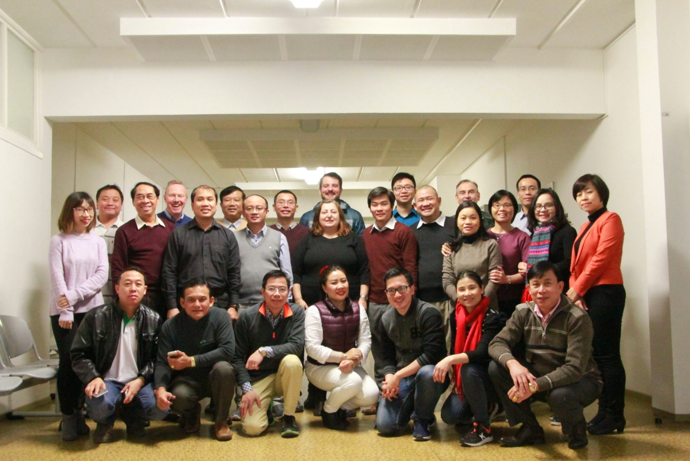

Summary
This training on preparation for Core Curricula development by the PC partners represented the second Language for Specific Purposes 2 training for vocational education in Vietnam and Laos. This was conducted according to the specialist skills of the individual EU partners and in some cases involved joint cooperation.
The training was conducted over a 9 day period. We found the facilities and organisation of the event to be very competent and participation of both national groups was consistently good with strong motivation. Detailed minutes were kept by selected B1+ PC colleagues as a statement of record and as a consolidation effort. Associated visits to a vocational education institution were very well received by the participants.
The following participants attended:
Partner | Organization | Name
P1 | UPB | Elisabeth Lazarou
P1 | UPB | Cristian Rene Anghelescu
P2 | TUD | Gerard Cullen
P2 | TUD | Sandra Erdmann
P2 | TUD | Sven Riddell
P3 | TPG | Margret Schäfer
P3  P4 | TPG  EHU | Susan Finke  David Allan
P4 | EHU | Fiona Hallett
P5 | LIT | Jerald Cavanagh
P5 | LIT | Padraig Kirby
P6 | HCMUTE | Nguyen Van Tuan
P6 | HCMUTE | Doanh Thi Kim Oanh
P6 | HCMUTE | Nguyen Vu Lan
P7 | HUTECH | Nguyen Duc Quang
P8 | HUST | Phuong Anh Ngo
P8 | HUST | Thi Le Hieu Dau
P8 | HUST | Ngoc Thai Hoa Pham
P9 | ULIS-VNU | Vu Hai Ha
P9 | ULIS-VNU | Nguyen Thuy Phuong Lan
P9 | ULIS-VNU | Nguyen Thi Thanh Van
P10 | UTEHY | Huu Hop Nguyen
P10 | UTEHY | Van Hau Nguyen
P10 | UTEHY | Hong Son VU
P11 | VUTED | Hoang Cong Anh
P11 | VUTED | Bui Thanh Hoa
P11 | VUTED | Tran Manh Cuong
P12 | NUoL | Bounseng Khammounty
P12 | NUoL | Xayyachack Sounvoravong
P12 | NUoL | Phannavong Bounphasouk
P12 | NUoL | Thavisone Mounlasane
P13 | UHS | Ketkesone Phrasisombath
P13 | UHS | Outhip Sounthavong
P13 | UHS | Kouherr Waxeng
The first task necessarily involved a review of LSP 1 training and outcomes of activities carried out between that time and now:

Review of training in Romania LSP 1 and feedback

- Strategies for Inclusion have yet to be implemented more widely
- Digital learning. Implementation of incorporating technology in teaching were reviewed. Some participants include Facebook, Google Class and Canvas Instructure in their teaching
- Information Processing: advantages and disadvantages discussed
- Technical shifts: what adaptation is necessary
- Cross disciplinary working
- Digital divide term discussed
- Assessment (Kahoot)
- Lightboard (intorduction as many were not familiar with this tool)
- Further Tools for learning
- Session outcomes
- Intellectual virtues
- Communicative approaches
- Multi-sensory teaching (eg. visual methodology)

Needs Analysis Survey
A questionnaire was provided and anaylsed, entitled
“Teachers Attitude to Inclusion Scale“.
The task for participants was to provide a translation of this into their native languages, and to assess whether they could agree on a common understanding of the terms used in the survey. The translations should be completed by Friday. Group work on this was started with trainer monitoring.
QA – A1-A2
Progress on ESP Pathway Program Module - English for Specific Purposes Training (terminology, soft skills, key writing skills) package for PCs based on in depth need analysis (developed and will be integrated into official university curricula for weaker staff and domestic/international students as a Pathway Program) was presented by each PC partner, discussed and followed with recommendations.

On the academic side the activities involved completing the curriculum training as indicated in the Training Programme.
After the training inputs the following Core Curricula Module Curriculum for Piloting 1, 2 and 3 was agreed by all EU and PC.

Overview of Final Modules for Piloting 1, Piloting 2 and Piloting 3 of Core Curriculum as reflected in LSP 1 Training in Bucharest and LSP 2 in Dresden:

Nr. | Short Description | Responsible EU-Partner
1 | Communicative Approach versus Traditional Approach in the classroom and use of oral skills for presenting, lecturing, public speaking.  Approach on Multiplication Factor Trainer for effective multiplicator at home and in domestic institutions.  NOTE: this module – DIVIDED INTO Module 1A for CA for General Vocational Education and Module 1B for CA for Vocational Language Education Training | EHU with TUD (for language learning CA)
2 | ICT/Blended/E-Learning based vocational teaching and learning approaches | EHU
3 | Innovation methodology in vocational teaching and learning (including the use of the internet/library/media centre for lesson development and implementation). | LIT
4 | Monitoring and evaluation of examination creation and assessment | UPB
5 | Recognition and validation of language skills in line with the Common European Framework of Reference (CEFR). Key languages are English and German. | TPG/TUD
6 | Language learning for vocational education purposes for internships and employment (CVs, letter of applications, interviews for domestic and international development in ASEAN block) | LIT/TPG/TUD
7 | Teaching for Diversity in vocational education for individuals with special needs and including a focus on intercultural awareness. Here teaching strategies will be designed to be fully inclusive, incorporating strong differentiation and the necessity to address special educational needs and disabilities (SEND) at vocational level. | EHU/LIT
8 | Module 8 Professional Development & Reflection | EHU
9 | Quality Assurance and Planning in vocational education (including observation, self-assessment techniques) | EHU

Module 10 Supplementary Modules

Module 10: ONGOING (AS QA Mechanism to support participation in project aims and objectives).
ESP Pathway Program Module - English for Specific Purposes Training in Vocational Education (terminology, soft skills, key writing skills) package for PCs based on in depth need analysis will be developed and will be integrated into official university curricula for weaker staff and domestic/international students as a Pathway Program.
Module 11: Catalyst Core Curricula Strategic Planning for Sustainability and Dissemination in Vocational Education
Use of ECTS and EU Tuning Frameworks in modular creation, CEFR. Official Accreditation Process for Core Curricula including Inter-University Module Recognition Agreements. (allowing participants to participate in modules not offered by a specific institution and gain transferable ECTS points thus employing best BP practice).
NEW
Module 12:
Introduction to Basic Vocational Writing Skills (business correspondence, emailing) TPG/TUD for Piloting 2
---------------------------------------------------------------------------------------------------------------------------
It was further agreed that all modules would be piloted separately in both countries keeping in mind country peculiarities. All modules were to be developed using ECTS guidelines and the Dublin Descriptors. Each module would have 4 documentary parts:
- CATALYST 1 - ECTS Module Description focusing on learning outcomes
- CATALYST 2 - WEEKLY AIMS & TEACHING INSTRUCTIONS FOR TRAINER
- CATALYST 3 - MODULE MATERIALS FOLDER
- CATALYST 4 - MODULE TEACHING RECORD

The templates are uploaded on QA on the project website. The following step was the Core Curricula Creation Teams which are as follows:
Module | HCMUTE | HUTECH | HUST | ULIS | UTEHY | VUTED | NUoL | UHS | Remark | EU module contact
Module 1A | Duong Thi Kim Oanh | Nguyen Lan Huong |  |  |  |  |  |  | Pilot | EHU
Module 1B |  | Nguyen Lan Huong |  | Vu Hai Ha |  |  |  |  | Pilot | TUD/TPG
Module 2 |  | Nguyen Lan Huong |  |  | Nguyen Huu Hop |  | Phannavong Bounphasouk | Ketkesone Phrasisobath | Pilot | EHU
Module 3 | Nguyen Vu Lan |  |  |  | Nguyen Huu Hop |  |  |  | Pilot | LIT
Module 4 | Duong Thi Kim Oanh |  |  | Vu Hai Ha |  |  |  |  | Pilot | UPB
Module 5 |  |  | Ngo Phuong Anh |  |  | Bui Thanh Hoa |  |  | Pilot | TUD/TPG
Module 6 |  |  | Ngo Phuong Anh |  |  |  | Mounlasane Thavisone | Kouherr Waxeng | Pilot | LIT/TPG/TUD
Module 7 | Nguyen Van Tuan |  |  |  |  |  |  | Ketkesone Phrasisombath | Pilot (General information & awareness) | EHU/LIT
Module 8 |  |  |  |  | Nguyen Huu Hop |  | Bounseng Khammounty |  | Pilot | EHU
Module 9 |  |  |  |  |  | Bui Thanh Hoa |  | Outhip Sounthavong | Pilot | EHU
Module 10 |  |  |  | Vu Hai Ha |  |  | Xayyachack Sounvoravong |  | Pilot | TUD/TPG
Module 11 |  |  |  |  |  | Bui Thanh Hoa | Bounseng Khammounty |  | Pilot (Training in ECTS) | TUD/TPG
Table 1: MODULE ARRANGEMENT REGISTRATION FOR 1st PILOTING OF CORE CURRICULA (to be conducted from June to October 2018, agreed in Dresden – 21.03.2018)

Note:
- Yellow highlight is the Module Leader.
- Deadline for Module description submission (to the EU Module responsible contact): 31 May 2018)
Corresponding Institutional Module leaders:

- HCMUTE: Duong Thi Kim Oanh oanhdtk@hcmute.edu.vn
- HUTECH: Nguyen Lan Huong nl.huong@hutech.edu.vn
- HUST: Ngo Phuong Anh anhbkhn@gmail.com
- ULIS: Vu Hai Ha haiha.cfl@gmail.com
- UTEHY: Nguyen Huu Hop huuhop78@gmail.com
- VUTED: Bui Thanh Hoa buithanhhoa.skv@gmail.com
- NUoL: Bounseng Khammuonty bounseng@fe-nuol.edu.la
- UHS: Ketkesone Phrasisombath ketkesonp@gmail.com

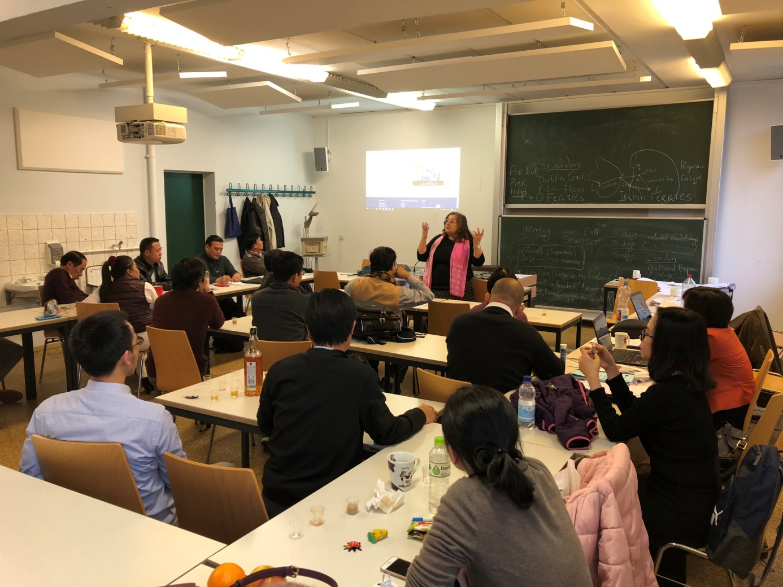
Conclusion – ACTION PLAN
The CBHE CATALYST project focuses on developing university vocational teachers teaching methodologies. The EU training is now complete and the next steps are for the PC partners to prepare, evaluate and pilot (three times) the Core Curricula.
All modules need to be prepared by 31 May and forwarded to the EU partners for QA evaluation and feedback.
The first Piloting will then commence in June (see below)
PC | Period of Piloting | Main objectives/expected outcomes | Evaluation EU Partners | Evaluation Period
NUoL | 1st - 8th September 2018 |  | EHU (September) | 1st - 8th September 2018
UHS | 1st - 8th September 2018 |  | EHU (September) | 1st - 8th September 2018
HUTECH | June - July 2018 |  | TUD (September) | 10th- 22nd September 2018
HUST | July- September 2018 |  | TUD (September) | 10th- 22nd September 2018
HCMUTE | 18th May 2018 ? |  | LIT (September) | 8th-16th July 2018
ULIS-VNU | August - September 2018 |  | TUD (September) | 10th- 22nd September 2018
UTEHY | July-August 2018 |  | TUD (September) | 10th- 22nd September 2018
VUTED | July- August 2018 |  | TUD (September) | 10th- 22nd September 2018
HCMUTE | Dec 2018 - Jan 2019
HUTECH | Jan-Feb 2019
HUST | Jan - Beginning March 2019
ULIS-VNU | Nov-Dec 2018
UTEHY | Nov-Dec 2018
VUTED | Nov-Dec 2018
NUoL | Nov-Dec 2018 |  | LIT | November/December 2018
UHS | Nov-Dec 2018 |  | LIT | November/December 2018
UHS | March-April 2019
NUoL | March-April 2019
HCMUTE | June-July 2019
HUST | May-August 2019
ULIS-VNU | March-April 2019
UTEHY | May-June 2019 |  | UPB
VUTED | May-June 2019 |  | UPB
HUTEC | April-May 2019

Comments
1st Piloting | April until September 2018
2nd Piloting | October 2018 until beginning March 2019
3rd Piloting | March until August 2019

The website was reviewed and Publicity Officers for each university were again informed of being responsible for the home university project link and updates plus uploads on to the project website.
QA A1-A2 training is a priority for all PC universities and will be monitoted.
We wish to thank all parties involved in making the training a successful one.
Gerard Cullen/Paul East
12 January 2018.
