Module Record of Training Activity: Module 10

ESP Pathway

Trainer: Nguyen Thi Thanh Van

Day: Pilot 1: 05, 06, 13, 20, 21, 24, 25 September and
4, 5, 10 and 11 October, 2018
Pilot 2: 7,8,14,21,22 May
and 11,12,18,19,25,26 April 2019

Time: 14.00 to 17.00 (3 hours)

Location: Room 207 Block B2- University of Languages and International Studies (ULIS)

Contents
LESSON 1 2
English Vocabulary for Specific Purposes (1) 2
LESSON 1 4
English Vocabulary for Specific Purposes (2) 4
LESSON 2 7
Public Speaking Skills 7
LESSON 3 14
How to Start a Presentation 14
LESSON 4 18
Ending your presentation 18
LESSON 5 22
Smooth structure of a presentation 22
LESSON 6 27
Developing ESP vocabulary through writing (1) 27
LESSON 6 32
Developing ESP vocabulary through writing (2) 32
LESSON 7 36
English Vocabulary for Specific Purposes (1) 36
LESSON 7 38
English Vocabulary for Specific Purposes (2) 38
LESSON 8 40
Public Speaking Skills 40
LESSON 9 45
How to Start a Presentation 45
LESSON 9 49
Ending your presentation 49
LESSON 10 53
Smooth structure of a presentation 53
LESSON 11 57
Developing ESP vocabulary through writing (1) 57
LESSON 11 62
Developing ESP vocabulary through writing (2) 62

LESSON 1

English Vocabulary for Specific Purposes (1)

Day: 05 September 2018 (3 hours)

Location: Room 207 Block B2- (ULIS)

No. | Content covered | Tasks given | Time allotted | Notes
 | Recognition of importance of ESP vocabulary in teaching and learning | - Participants wrote down some words that relate to their own field and explain why they have chosen the words  - They were asked to work in groups to discuss the roles of vocabulary in ESP teaching and learning and presented their ideas to the class. | 10 minutes  30 minutes | - The teacher should focus more on roles of ESP vocabulary in ESP teaching and learning
 | Classification of vocabulary into part of speech and tiers | - The teacher explained the way of classifying words according to their part of speech and into tiers  - Students were requested to work in pairs/groups of three to identify the part of speech of words in the given sentences and then present their answers in the class.  - The teacher asked the students to watch a short video clip about the importance of various kinds of vocabulary and asked them to discuss their ideas in groups  https://www.youtube.com/watch?v=OetbzrP2QUU&t=115s  - The teacher asked students to work in pairs and gave them a reading passage to classify their unknown words into tiers | 10 minutes  15 minutes  15 minutes  25 minutes | - Some students found the clips a bit difficult to catch the ideas. Therefore, the teacher should allow them to watch again  - This activity was useful to students. However, they needed more time as well as teacher’s support
 | Selection of words to teach in an ESP lesson | - The students were given a handout of questions to select words and asked them to work with their partners to choose the useful words to teach  - The teacher asked them to identify the types of questions they should raise when they had to choose words to teach in their class | 40 minutes  20 minutes | It was a great activity to students. The teacher should give further explanation on types of questions which should be raised when choosing words to teach
 | Wrap up | - Participants wrote a short paragraph to summary main points of how to select words to teach in an ESP lesson | 30 minutes | Students reacted enthusiastically

LESSON 1

English Vocabulary for Specific Purposes (2)

Day: 06 September 2018 (4 hours)
Location: Room 207 Block B2- (ULIS)
No. | Content covered | Tasks given | Time allotted | Notes
 | Techniques for teaching ESP vocabulary | - Students were required to brainstorm the techniques that they could use to teach vocabulary and discuss their procedure  - Then the teacher gave them some words and required them to choose the useful technique to teach the particular word  - The teacher asked some voluntary students to teach some words by using various techniques. Other students acted as learners, then they gave some comments. | 30 minutes  40  minutes  20 minutes | Some students did not have enough time to practise. Give them some more minutes  This activity was really useful to students because they can understand how to apply these techniques into real-life contexts. Especially, they could learn a lot from their teacher’s and peers’ comment
 | Application of modern technology in teaching and learning vocabulary | - Participants discussed about merits of using technology in teaching and learning ESP vocabulary  - Participants designed a vocabulary test for applying Kahoot in teaching and learning ESP vocabulary.  - The teacher asked students to sign in https://quizizz.com/ to design another ESP vocabulary test | 20 minutes  50  minutes  50  minutes | The teacher should wrap up the advantages of using technology to teach vocabulary.  Students were very interested in the tool and felt it useful. However, some students still had some technical problems when designing tests. The teacher should go around and gave them support
 | Wrap up | - Participants can try some vocabulary tests designed by their classmates via the internet | 30 minutes | Students reacted enthusiastically and thoroughly understood what happened in a class using technology to teach ESP vocabulary

LESSON 2

Public Speaking Skills

Day: 13 September 2018

Location: Room 207 Block B2- (ULIS)

No. | Content covered | Tasks given | Time allotted | Notes
 | Public speaking skills– Introduction to Speaking Skills | - Think – Pair - Share  - Students activate prior knowledge of good examples of public speaking skills by reflecting on their own experiences, sharing with a partner, then with the whole class.They thought quietly for one minute, then turned to a partner and shared their answers.  - The T shows the class two video examples of presentations then discusses and records what was good and bad about each video.  Materials/Prep:  Video 1: https://www.youtube.com/watch?v=YivQYeI0vys&list=PL0A6F488037FF5613&index=2  Video 2: http://www.youtube.com/watch?v=8K720D6nwkc  - Students analyzed the presenters’ delivery styles and decided which speaking practices were positive and would engage the audience, and which ones were poor and would cause the audience to disengage.  - Students watched video clips and worked in pairs or small groups to fill out the sections | 30 minutes | - Students felt more comfortable to have time to think before they share answers.  - Students were enthusiastic to work in groups and have various opinions  - If students language level is low, let them watch again before discussing with partners.
 | Building Up Speaking Skills | - The class stood in a circle with the teacher. The teacher explained that they were going to explore some skills for public speaking, and that this would be a chance for everyone to experience using these skills. All of the students practiced together, then each student took a turn saying the lines while incorporating the speaking skills. By the end of the activity, all of the Ss should be speaking the lines while incorporating a confident stance, speaking loudly, smiling, making eye contact, and using hand gestures. | 40 minutes | - All students should have a chance to practice what they will say out loud.  - This activy could actract a lot of students to participate and gave the chance to speak
 | Speaking Skills Feedback | - The teacher handed out copies of the Speaking Skills Rating Sheet, and asked the students to read through it. The teacher explained that the students would be giving short impromptu presentations, and that they would be rated by their peers on the five speaking practices that were just covered in the previous activity. The teacher asked the students to talk for 30-45 seconds about a familiar topic (Ex: family members, a past vacation, their school, etc.) The teacher should give the class 2-3 minutes to write down basic notes on what they would talk about.  Materials/Prep:  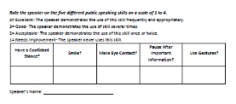  - The teacher divided the class up into partners or small groups. One of the students was the speaker. The students who weren’t speaking were responsible for observing and rating the speaker. The students who were the speakers stood up and delivered their presentation to their partner or small group. The listeners observed the speakers, then used the rubric to score their speaking skills. Next, the students switched roles, and the speaker became the observer. | 50 minutes | - If students are unfamiliar with using a rating rubric, the teacher may need to demonstrate its use by first modeling a short presentation, then having the class use the rubric formula to rate them on their incorporation of the five speaking skills.  - All students should have a chance to practice this rating based on the rubric.  - For better utilising the rubric, ask students why they choose to rate others as they do.
 | Wrap-Up: Personal Goal Setting | - The teacher asked students to write down two personal goals that they had for improving their public speaking skills, based on the day’s lesson. | 55 minutes | - If they did not want to write down, teacher may ask them to share orally with a friend or with the whole class.
 | Homework | - The teacher asked students to use their Idea Map Graphic Organizer to brainstorm ideas for a 15-minute presentation of the own chosen topic. The topic should be based on what the class was currently studying.  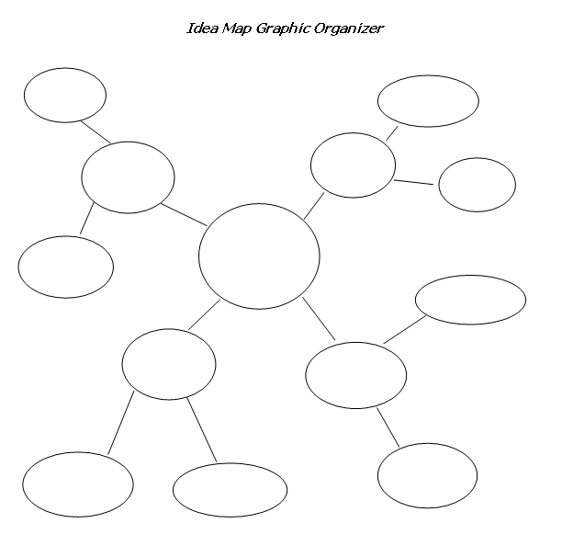 | 5 minutes | - Students seemed to be interested in this task though it may seemed a bit hard to some with lower language proficiency, so the teacher could help them with some supporting ideas

LESSON 3

How to Start a Presentation

Day: 20 and 21 September 2018 (5 hours)

Location: Room 207 Block B2- (ULIS)

No. | Content covered | Tasks given | Time allotted | Notes
 | Warm-Up: Review | - Teacher asked students to work in pairs or groups to re-read the section on introduction on their worksheet from the previous day. | 30 minutes | - Students needed more time
 | Name the Element of an Introduction | - Teacher requested students to work independently to complete the worksheet, first reading the examples of parts of an oral presentation introduction, and then labeling them with the corresponding element.  Materials/Prep:  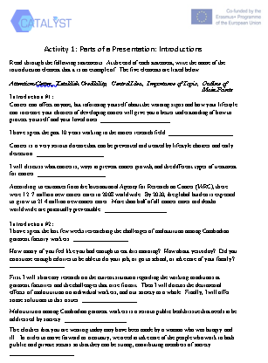 | 60 minutes | - Students may be asked to work individually, but some prefer to work in pairs.
 | Types of Attention-Getters | - Students watched clips and names Types of Attention-Getters  Materials/Prep:  MODULE 10 - MODULE MATERIALS FOLDER\Module 10 - Lesson 3\Using quotes to open.mp4  MODULE 10 - MODULE MATERIALS FOLDER\Module 10 - Lesson 3\Using Retorical questions.mp4  MODULE 10 - MODULE MATERIALS FOLDER\Module 10 - Lesson 3\Using Shocking Statistics.mp4  MODULE 10 - MODULE MATERIALS FOLDER\Module 10 - Lesson 3\Using stories.mp4  MODULE 10 - MODULE MATERIALS FOLDER\Module 10 - Lesson 3\Attention getter 6.mp4  MODULE 10 - MODULE MATERIALS FOLDER\Module 10 - Lesson 3\Getting audience involved.mp4  - Students discussed advantages and disadvanages of the types of attention getter.  - Students noted what to remember when applying the attention getter  - Students matched types of attention getter with sentences of introduction.  Materials/Prep:  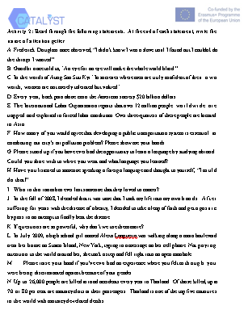  - Students found out the function of the elements (in task 1) in the introduction.  - Survey :The teacher conducted a brief class survey, asking the class which attention-getter strategies they believed were the most effective, and which ones the Ss were interested in using for in their own oral presentation | 90 minutes | - If some students may have lower proficiency levels so teacher may let them watch again.  - Students tended to prefer to work in pair or groups for more sharing.  - Students were quite excited about this activity because they could move around and talk to various people.
 | Introduction Practice | - Students were required to work in pairs/ groups of three to practise the introduction to the topic that they had chosen from the previous lesson. Other students listened to the presenter and discussed his/her good and bad points after the practice | 100 minutes | Students found this activity intersting, useful and practical. They could reconfirmed the techniques for making an effective introduction of a presentation
 | Wrap-Up: Personal Goal Setting | - The teacher asked the students to write down two personal goals that they had for improving their public speaking skills, based on the day’s lesson. | 20 minutes | - If they do not want to write down, teacher may ask them to share orally with a friend or with the whole class.
 | Homework: Write an Attention-Getter | - The teacher selected a topic for the class. Students were asked to write two different types of attention-getters for an oral presentation introduction based on the topic. The topic should base on what the class is currently studying | 3 minutes | - Students may not want to do this homework so teachers may ask them to write one. Or if there is still time, this can be done right at the end of the lesson.

LESSON 4

Ending your presentation

Day: 24 and 25 September 2018 (4 hours)

Location: Room 207 Block B2- (ULIS)

No. | Content covered | Tasks given | Time allotted | Notes
 | Warm-Up:  Conclusion Word Association | - The teacher askedstudents to work in pairs to think of as many words as they could that were associated with conclusions.  - The teacher signaled the end of the time and asks how many words each pair has. T asked for volunteers to share some of the words they came up with | 20 minutes | - It was very useful to students. They found really exciting to know how to conclude presentations effectively. The teacher should help them by giving them a list of words, signals to end their presentation.
2. | Development Activity 1: Features of Effective Conclusion and Conclusion Slides | - Students were given opportunities to watch some video clips in which the presenters had concluded their presentations which sts saw their introductions in the previous lesson and identify which technique the presenter had used to conclude and then discussed with their partner.  Materials/Prep:  MODULE 10 - MODULE MATERIALS FOLDER\Module 10 - Lesson 4\Closing presentation 1.mp4  MODULE 10 - MODULE MATERIALS FOLDER\Module 10 - Lesson 4\Closing presentation 2.mp4  MODULE 10 - MODULE MATERIALS FOLDER\Module 10 - Lesson 4\Closing presentatin 3.mp4  - The teacher asked some pairs to list the techniques and then show them the benefits of using these techniques to end  - The teacher presented the Features of Effective Conclusion SlidesPowerPoint, and talked through each slide with the class, answering questions as needed.  Materials/Prep:  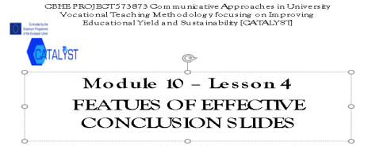 | 30 minutes | - Students should be allowed to watch the clips again because some of them found it difficult to catch the information
3. | Development Activity 2: Drafting of Introductions, Conclusions, Conclusion Slides | The teacher asked students to use their Idea Map Graphic Organizer from Lesson 2.  For the purpose of a 15-minute presentation, Ss were requested to work indepently to prepare their own introduction, conclusion and conclusion slides for their presentation.  The teacher held a brief mini-conferences with each S (about 2 minutes, depending on the number of Ss) to quickly look over his/her introduction, conclusion and PowerPoint design so far and to prioritize a few issues to work on. | 55 minutes | - Students tended to prefer to work in pair or groups for more sharing.  - Students found it interesting
4. | Finishing Strong: Rehearsing Introductions and Conclusions | The teacher formed groups of 3-4 either by purposefully mixing Ss to work with new classmates | 90 minutes | - Students were quite excited about this activity because they could move around and talk to various people.
5. | Review: Class Rating of PowerPoint | Materials/Prep:  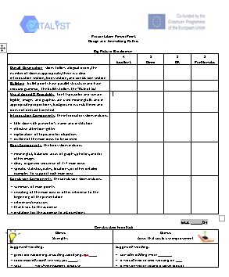  The teacher handed out 2 blank copies of the Design and Formatting Rubric to each S. T asked Ss to turn to a partner and handed each pair hard copies of the 2Full PowerPoint Samples.  After about 15 minutes, T reconvened the whole class.  The teacher handed a Talking Stick to each student and explainedthat they would be used in the class discussion of the ratings. | 30 minutes | - To some extent it was a little bit difficult for students. The teacher should explain more clearly
6. | Wrap-up and homework | The teacher wrapped up the lesson and the unit by restating some of the objectives that had been met and the significance of these skills in the greater context of students’ careers.  The teacher asked students to practise some ways of ending their presentations which they are interested in | 15 minutes | - It was useful. Students could remember what they had learnt

LESSON 5

Smooth structure of a presentation

Day: 4 and 5 October 2018 (5 hours)

Location: Room 207 Block B2- (ULIS)

No. | Content covered | Tasks given | Time allotted | Notes
1. | Warm-Up: | - The teacher asked students to watch a short video clip about importance of smooth structure in a presentation  Materials/Prep:  MODULE 10 - MODULE MATERIALS FOLDER\Module 10 - Lesson 5\02 Smooth Structure.mkv  - The class was required to elicit ways in which a presentation might be like a journey and read the quote to compare it with their ideas.  - After both partners had had a chance to speak (1-2 minutes), the teacher brought everyone back together and partners shared their answers with the whole class. The teacher recorded responses on the board | 30 minutes | - It sounded interesting to students because they were eager to understand what they had to do to join their prepared ideas into a perfect presentation
2. | Development Activity 1: Signposting the presentation | - The teacher explained to the class that If a presentation was a kind of journey, then the ability to signpost that journey was clearly critical and ask them to complete the exercise in pairs and then feed back to the class.  Materials/Prep:  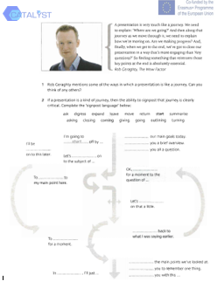  - While studentswere completing the exercise, draw the diagram (only the arrows) onto the board. Then tell students to close their books to remember the useful phrases for each section.  - Elicit from the class why the verb was sometimes in the infinitive (with or without to) and sometimes in the -ing form. | 50 minutes | - Some students found it difficult to do the exercise such as new words because they did not know the way to use these linking words smoothly. Therefore the teacher could support them by giving them some explanation
3. | Development Activity 2: Building up Speaking skills | - Elicit from the class the advantages and disadvantages of referring to points the teacher made earlier and mentioning what the teacher would be talking about next. Students then read the introduction and the quote to see if they mentioned the same ideas. | 70 minutes | - Should spend more time
4. | Activity 3: Speaking skills: Logical links | - The teacher handed out copies of the Logical link, and asked the students to work in pairs to complete the exercise and then listened to check their answers. Go through the answers with the class to deal with any problems.  Materials/Prep:  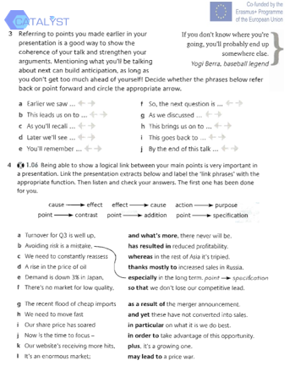  - Students covered the right-hand column and test each other in pairs by reading the left-hand column to elicit the continuation from their partner. | 50 minutes | - This activity was really useful because students had an opportunity to recall the way to use these linking words.  - Next time, the teacher can help students understand the meaning and usage of the signposts clearly before
5. | Activity 4: The Signpost Maze Game | The teacher divided the class up into partners or small groups. One of the students was the speaker. Students worked in pairs to play the game.  Materials/Prep:  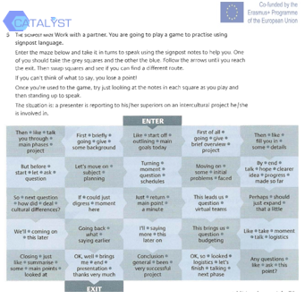 | 80 minutes | - Very interesting because it could motivate students to speak out. However, some pairs were not very active, so the teacher should go around the class and made sure they were engaged
6. | Wrap-up: Personal Goal Setting | The teacher askedstudents to write down two personal goals that they had for improving their public speaking skills, based on the day’s lesson. | 20 minutes

LESSON 6

Developing ESP vocabulary through writing (1)

Day: 10 October 2018 (3,5 hours)

Location: Room 207 Block B2- (ULIS)

No. | Content covered | Tasks given | Time allotted | Notes
1. | Warm-Up: | - The teacher asked students to work in pairs to identify the part of speech of words in the handout 1  Materials/Prep:  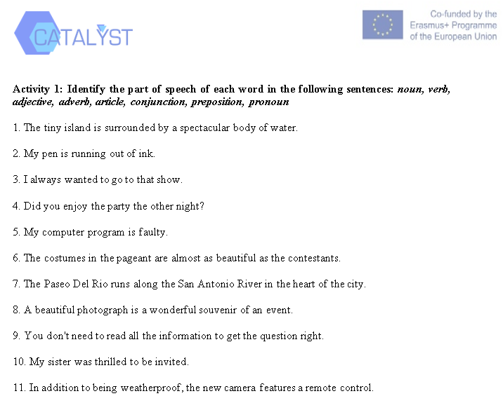 | 20 minutes | - Some students did not know the way to identify the part of speech of words. The teacher should raise some question to help them
2. | Word class and word order to form sentence (word, phrase or clause) | - The teacher asked students to work in groups to figure out the roles of various kinds of English words in writing  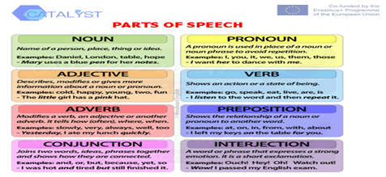  - The teacher delivered the above handout to students  - The teacher divided the class into teams of five, gave each group a piece of paper for writing and explained that the students were racing to make sentences using only words that began with certain letter and particular part of speech. The first team which could make a grammatically correct sentence scored one point.  For example: letter M as a noun  My mother makes a morning meal.  In their teams, the students work together to come up with a sentence.  The first team to raise their hand can answer.  If the sentence is correct, award that team points accordingly.  Then, move on to another letter.  If the sentence is grammatically incorrect, that team is out of the round and no points are awarded. Another team can then try to  answer.  Play several rounds using a different words of various parts of speech each time.  The team with the most points at the end of the game wins. | 20 minutes  30 minutes | - After students discussed and presented the roles of words in writing, the teacher noted them on board  When students made incorrect sentences, the teacher should explain why
3. | Sentence Structures | Materials/Prep:  https://www.youtube.com/watch?v=smgyeUomfyA  - The teacher asked students to watch the video clipand noted down main differences among sentence structures  - The teacher further explained the way to form simple, compound, complex, compound complex sentences to students  - The teacher wrote a phrase on the board. The students then had to take it in turns to add extra words to make it into a longer and longer sentence. The trick was that it had to always remain a coherent sentence. No words could be removed although they could be moved around to change the order.  For example  Example:  the old man  I saw the old man.  I saw the old man yesterday.  I was in town when I saw the old man yesterday.  I was working in town when I saw the old man yesterday.  I was working in town when I saw the deaf old man yesterday.  I was working in town when I saw the deaf old man in the shop yesterday.  I was working in the town where my sister lives when I saw the deaf old man in the shop yesterday.  ... and so on.  - The teacher wrote a long sentence on the board and the students had to remove words and phrases while ensuring that it always remained as a sentence.  For example:  The sad and lonely young Egyptian student who lived above my flat was always playing these long and beautiful Arabic songs on the wonderful wooden mandolin which he kept wrapped up in a sheepskin bag and hidden underneath the hard metal bed that he slept on.  • The teacher delivered handouts for Activity 2 and asked the students to work with their partners to find out the answers  Materials/Prep:  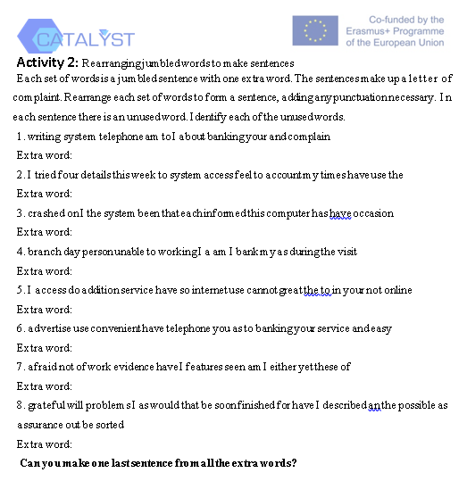  - The teacher gave them handouts for Activity 3 and divided the class into two teams. Each team was given two pieces of paper A3 and asked to diagram the compound complex sentences, then present to the whole class. | 40 minutes  30 minutes  20 minutes  40 minutes | - The teacher should explainmore about these types of sentences to help students understand thoroughly  - Some students did not have the ability to find out the exact answer.  - The teacher should give some techniques. (s)he should explain to them differences among various kinds of sentences, which can be easier for them in this activity  - Some students could not finish all the sentences within the given period of time. Next time, the teacher could give them some more time
4. | Wrap up/ Homework | - The teacher raised some questions about parts of speech and sentence structures and called some students to answer  - The teacher asked students to watch the video clip at home to understand more about different parts of speech in English and write a short summary  Materials/Prep:  https://www.youtube.com/watch?v=v9fCKTwytJA | 10 minutes | - The teacher should ask students to pay more attention to the functions of different parts of speech to help them write correct sentences in the future

LESSON 6

Developing ESP vocabulary through writing (2)

Day: 11 October 2018 (2,5 hours)

Location: Room 207 Block B2- (ULIS)

No. | Content covered | Tasks given | Time allotted | Notes
1. | Warm-Up: | - Every student had a blank piece of paper and pen.  - The teacher provided the story starter “I knew it was a bad idea to…”  - The students wrote the story starter at the top of the page and then started writing the story.  - The teacher set the timer (2 minutes or so); when the timer went off, the students had to pass their paper back to the person behind them. The last person in the row, ran her paper up to the first person. Students had to stop writing when the teacher called time — even if they were in the middle of a sentence!  - Continue with each student down the row adding to the story.  - After a few rounds, students ended up with their own paper again. They then needed to write a conclusion to their story.  - The teacher gave some reasons why some students found it difficult to finish the sentence in time | 20 minutes | - Some students did not finish their sentence when the time was over. The teacher should call these students to explain the reason why they had not finished
2. | Understanding a writing process | - The teacher explained the steps of writing process and asked students to watch a video clip and jotted down what the writer had to do in each step.  Materials/Prep:  https://www.youtube.com/watch?v=kbP0P8Wxtcg  - The teacher delivered handouts for Activity 1 to the class and asked students to match the correct stage of a writing process with the correct questions  Materials/Prep:  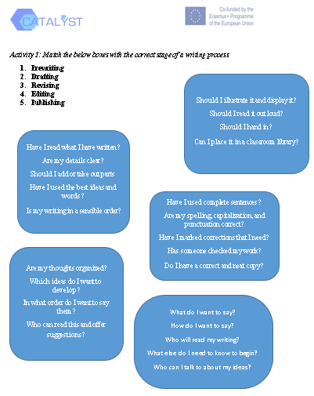 | 20 minutes  15 minutes | - After students discussed and presented the roles of words in writing, the teacher noted them on board  - When students made incorrect sentences, the teacher should explain why
3. | Building a paragraph from sentences | - Students were given handouts for Activity 2. They are asked to compare two paragraphs to find out which paragraph was better and explained why  Materials/Prep:  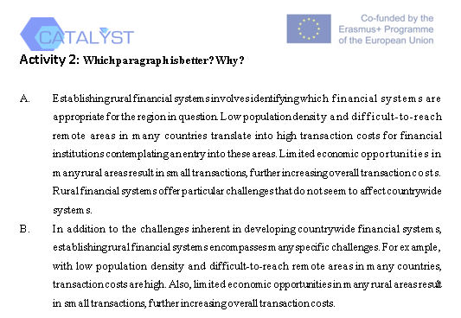  - The teacher helped students understand the definition of a good paragraph clearly by playing a short video clip and asked them to write down main parts of a paragraph and their functions. The students were also requested to recognize the difference between a paragraph and a sentence  Materials/Prep:  https://www.youtube.com/watch?v=xI0avBnnPCc  - The teacher delivered a handouts and asked students to rearrange these sentences into a paragraph  Materials/Prep:  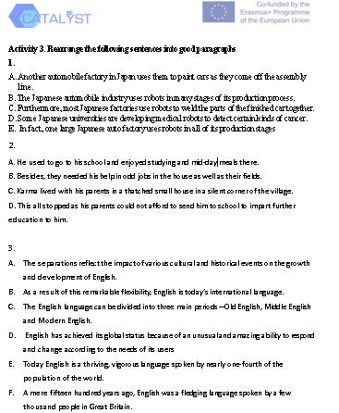  - The teacher requiredstudents to choose one topic of their interest and practise writing a paragraph in the given period of time | 15 minutes  20 minutes  30 minutes  20 minutes | - Useful to help students to define what a paragraph was  - After the students gave their own answers to the given questions, the teacher should summarize them  - Sometimes the teacher had to explain the correct order of sentences in the paragraph more clearly
5. | Wrap up | - The teacher raised some questions about the steps of writing paragraph, functions of sentences in a paragraphs and wrote a reflection paragraph about what they had learnt | 10 minutes | - Interactive

LESSON 7

English Vocabulary for Specific Purposes (1)

Day: 7 March 2019 (3 hours)

Location: Room 207 Block B2- (ULIS)

No. | Content covered | Tasks given | Time allotted | Notes
 | Recognition of importance of ESP vocabulary in teaching and learning | - Participants wrote down some words that relate to their own field and explain why they have chosen the words  - They were asked to work in groups to discuss the roles of vocabulary in ESP teaching and learning and presented their ideas to the class. | 10 minutes  30 minutes | - The teacher should focus more on roles of ESP vocabulary in ESP teaching and learning
 | Classification of vocabulary into part of speech and tiers | - The teacher explained the way of classifying words according to their part of speech and into tiers  - Students were requested to work in pairs/groups of three to identify the part of speech of words in the given sentences and then present their answers in the class.  - The teacher asked the students to watch a short video clip about the importance of various kinds of vocabulary and asked them to discuss their ideas in groups  https://www.youtube.com/watch?v=OetbzrP2QUU&t=115s  - The teacher asked students to work in pairs and gave them a reading passage to classify their unknown words into tiers | 10 minutes  15 minutes  15 minutes  25 minutes | - Some students found the clips a bit difficult to catch the ideas. Therefore, the teacher should allow them to watch again  - This activity was useful to students. However, they needed more time as well as teacher’s support
 | Selection of words to teach in an ESP lesson | - The students were given a handout of questions to select words and asked them to work with their partners to choose the useful words to teach  - The teacher asked them to identify the types of questions they should raise when they had to choose words to teach in their class | 40 minutes  20 minutes | It was a great activity to students. The teacher should give further explanation on types of questions which should be raised when choosing words to teach
 | Wrap up | - Participants wrote a short paragraph to summary main points of how to select words to teach in an ESP lesson | 30 minutes | Students reacted enthusiastically so they can remember important notes of the lesson.

LESSON 7

English Vocabulary for Specific Purposes (2)

Day: 08 March 2019 (4 hours)
Location: Room 207 Block B2- (ULIS)
No. | Content covered | Tasks given | Time allotted | Notes
 | Techniques for teaching ESP vocabulary | - Students were required to brainstorm the techniques that they could use to teach vocabulary and discuss their procedure  - Then the teacher gave them some words and required them to choose the useful technique to teach the particular word  - The teacher asked some voluntary students to teach some words by using various techniques. Other students acted as learners, then they gave some comments. | 30 minutes  40  minutes  20 minutes | Some students did not have enough time to practise. Give them some more minutes  This activity was really useful to students because they can understand how to apply these techniques into real-life contexts. Especially, they could learn a lot from their teacher’s and peers’ comment
 | Application of modern technology in teaching and learning vocabulary | - Participants discussed about merits of using technology in teaching and learning ESP vocabulary  - Participants designed a vocabulary test for applying Kahoot in teaching and learning ESP vocabulary.  - The teacher asked students to sign in https://quizizz.com/ to design another ESP vocabulary test | 20 minutes  50  minutes  50  minutes | The teacher should wrap up the advantages of using technology to teach vocabulary.  Students were very interested in the tool and felt it useful. However, some students still had some technical problems when designing tests. The teacher should go around and gave them support
 | Wrap up | - Participants can try some vocabulary tests designed by their classmates via the internet | 30 minutes | Students reacted enthusiastically and thoroughly understood what happened in a class using technology to teach ESP vocabulary

LESSON 8

Public Speaking Skills

Day: 14 March 2019 (3 hours)

Location: Room 207 Block B2- (ULIS)

No. | Content covered | Tasks given | Time allotted | Notes
 | Public speaking skills– Introduction to Speaking Skills | - Think – Pair - Share  - Students activate prior knowledge of good examples of public speaking skills by reflecting on their own experiences, sharing with a partner, then with the whole class.They thought quietly for one minute, then turned to a partner and shared their answers.  - The T shows the class two video examples of presentations then discusses and records what was good and bad about each video.  Materials/Prep:  Video 1: https://www.youtube.com/watch?v=YivQYeI0vys&list=PL0A6F488037FF5613&index=2  Video 2: http://www.youtube.com/watch?v=8K720D6nwkc  - Students analyzed the presenters’ delivery styles and decided which speaking practices were positive and would engage the audience, and which ones were poor and would cause the audience to disengage.  - Students watched video clips and worked in pairs or small groups to fill out the sections | 30 minutes | - Students felt more comfortable to have time to think before they share answers.  - Students were enthusiastic to work in groups and have various opinions  - If students language level is low, let them watch again before discussing with partners.
 | Building Up Speaking Skills | - The class stood in a circle with the teacher. The teacher explained that they were going to explore some skills for public speaking, and that this would be a chance for everyone to experience using these skills. All of the students practiced together, then each student took a turn saying the lines while incorporating the speaking skills. By the end of the activity, all of the Ss should be speaking the lines while incorporating a confident stance, speaking loudly, smiling, making eye contact, and using hand gestures. | 40 minutes | - All students should have a chance to practice what they will say out loud.  - This activy could actract a lot of students to participate and gave the chance to speak
 | Speaking Skills Feedback | - The teacher handed out copies of the Speaking Skills Rating Sheet, and asked the students to read through it. The teacher explained that the students would be giving short impromptu presentations, and that they would be rated by their peers on the five speaking practices that were just covered in the previous activity. The teacher asked the students to talk for 30-45 seconds about a familiar topic (Ex: family members, a past vacation, their school, etc.) The teacher should give the class 2-3 minutes to write down basic notes on what they would talk about.  Materials/Prep:  - The teacher divided the class up into partners or small groups. One of the students was the speaker. The students who weren’t speaking were responsible for observing and rating the speaker. The students who were the speakers stood up and delivered their presentation to their partner or small group. The listeners observed the speakers, then used the rubric to score their speaking skills. Next, the students switched roles, and the speaker became the observer. | 50 minutes | - If students are unfamiliar with using a rating rubric, the teacher may need to demonstrate its use by first modeling a short presentation, then having the class use the rubric formula to rate them on their incorporation of the five speaking skills.  - All students should have a chance to practice this rating based on the rubric.  - For better utilising the rubric, ask students why they choose to rate others as they do.
 | Wrap-Up: Personal Goal Setting | - The teacher asked students to write down two personal goals that they had for improving their public speaking skills, based on the day’s lesson. | 55 minutes | - If they did not want to write down, teacher may ask them to share orally with a friend or with the whole class.
 | Homework | - The teacher asked students to use their Idea Map Graphic Organizer to brainstorm ideas for a 15-minute presentation of the own chosen topic. The topic should be based on what the class was currently studying. | 5 minutes | - Students seemed to be interested in this task though it may seemed a bit hard to some with lower language proficiency, so the teacher could help them with some supporting ideas

LESSON 9

How to Start a Presentation

Day: 21 and 22 March 2019 (5 hours) (Approximately 2.5 hours each day)

Location: Room 207 Block B2- (ULIS)

No. | Content covered | Tasks given | Time allotted | Notes
 | Warm-Up: Review | - Teacher asked students to work in pairs or groups to re-read the section on introduction on their worksheet from the previous day. | 30 minutes | - Students needed more time
 | Name the Element of an Introduction | - Teacher requested students to work independently to complete the worksheet, first reading the examples of parts of an oral presentation introduction, and then labeling them with the corresponding element.  Materials/Prep: | 60 minutes | - Students may be asked to work individually, but some prefer to work in pairs.
 | Types of Attention-Getters | - Students watched clips and names Types of Attention-Getters  Materials/Prep:  MODULE 10 - MODULE MATERIALS FOLDER\Module 10 - Lesson 3\Using quotes to open.mp4  MODULE 10 - MODULE MATERIALS FOLDER\Module 10 - Lesson 3\Using Retorical questions.mp4  MODULE 10 - MODULE MATERIALS FOLDER\Module 10 - Lesson 3\Using Shocking Statistics.mp4  MODULE 10 - MODULE MATERIALS FOLDER\Module 10 - Lesson 3\Using stories.mp4  MODULE 10 - MODULE MATERIALS FOLDER\Module 10 - Lesson 3\Attention getter 6.mp4  MODULE 10 - MODULE MATERIALS FOLDER\Module 10 - Lesson 3\Getting audience involved.mp4  - Students discussed advantages and disadvanages of the types of attention getter.  - Students noted what to remember when applying the attention getter  - Students matched types of attention getter with sentences of introduction.  Materials/Prep:  - Students found out the function of the elements (in task 1) in the introduction.  - Survey :The teacher conducted a brief class survey, asking the class which attention-getter strategies they believed were the most effective, and which ones the Ss were interested in using for in their own oral presentation | 90 minutes | - If some students may have lower proficiency levels so teacher may let them watch again.  - Students tended to prefer to work in pair or groups for more sharing.  - Students were quite excited about this activity because they could move around and talk to various people.
 | Introduction Practice | - Students were required to work in pairs/ groups of three to practise the introduction to the topic that they had chosen from the previous lesson. Other students listened to the presenter and discussed his/her good and bad points after the practice | 100 minutes | Students found this activity intersting, useful and practical. They could reconfirmed the techniques for making an effective introduction of a presentation
 | Wrap-Up: Personal Goal Setting | - The teacher asked the students to write down two personal goals that they had for improving their public speaking skills, based on the day’s lesson. | 20 minutes | - If they do not want to write down, teacher may ask them to share orally with a friend or with the whole class.
 | Homework: Write an Attention-Getter | - The teacher selected a topic for the class. Students were asked to write two different types of attention-getters for an oral presentation introduction based on the topic. The topic should base on what the class is currently studying | 3 minutes | - Students may not want to do this homework so teachers may ask them to write one. Or if there is still time, this can be done right at the end of the lesson.

LESSON 9

Ending your presentation

Day: 11 and 12 April 2019 (4 hours) (Approximately 2 hours each day)

Location: Room 207 Block B2- (ULIS)

No. | Content covered | Tasks given | Time allotted | Notes
 | Warm-Up:  Conclusion Word Association | - The teacher askedstudents to work in pairs to think of as many words as they could that were associated with conclusions.  - The teacher signaled the end of the time and asks how many words each pair has. T asked for volunteers to share some of the words they came up with | 20 minutes | - It was very useful to students. They found really exciting to know how to conclude presentations effectively. The teacher should help them by giving them a list of words, signals to end their presentation.
2. | Development Activity 1: Features of Effective Conclusion and Conclusion Slides | - Students were given opportunities to watch some video clips in which the presenters had concluded their presentations which sts saw their introductions in the previous lesson and identify which technique the presenter had used to conclude and then discussed with their partner.  Materials/Prep:  MODULE 10 - MODULE MATERIALS FOLDER\Module 10 - Lesson 4\Closing presentation 1.mp4  MODULE 10 - MODULE MATERIALS FOLDER\Module 10 - Lesson 4\Closing presentation 2.mp4  MODULE 10 - MODULE MATERIALS FOLDER\Module 10 - Lesson 4\Closing presentatin 3.mp4  - The teacher asked some pairs to list the techniques and then show them the benefits of using these techniques to end  - The teacher presented the Features of Effective Conclusion SlidesPowerPoint, and talked through each slide with the class, answering questions as needed.  Materials/Prep: | 30 minutes | - Students should be allowed to watch the clips again because some of them found it difficult to catch the information
3. | Development Activity 2: Drafting of Introductions, Conclusions, Conclusion Slides | The teacher asked students to use their Idea Map Graphic Organizer from Lesson 2.  For the purpose of a 15-minute presentation, Ss were requested to work indepently to prepare their own introduction, conclusion and conclusion slides for their presentation.  The teacher held a brief mini-conferences with each S (about 2 minutes, depending on the number of Ss) to quickly look over his/her introduction, conclusion and PowerPoint design so far and to prioritize a few issues to work on. | 55 minutes | - Students tended to prefer to work in pair or groups for more sharing.  - Students found it interesting
4. | Finishing Strong: Rehearsing Introductions and Conclusions | The teacher formed groups of 3-4 either by purposefully mixing Ss to work with new classmates | 90 minutes | - Students were quite excited about this activity because they could move around and talk to various people.
5. | Review: Class Rating of PowerPoint | Materials/Prep:  The teacher handed out 2 blank copies of the Design and Formatting Rubric to each S. T asked Ss to turn to a partner and handed each pair hard copies of the 2Full PowerPoint Samples.  After about 15 minutes, T reconvened the whole class.  The teacher handed a Talking Stick to each student and explainedthat they would be used in the class discussion of the ratings. | 30 minutes | - To some extent it was a little bit difficult for students. The teacher should explain more clearly
6. | Wrap-up and homework | The teacher wrapped up the lesson and the unit by restating some of the objectives that had been met and the significance of these skills in the greater context of students’ careers.  The teacher asked students to practise some ways of ending their presentations which they are interested in | 15 minutes | - It was useful. Students could remember what they had learnt

LESSON 10

Smooth structure of a presentation

Day: 18 and 19 April (5 hours) (Approximately 2.5 hours each day)

Location: Room 207 Block B2- (ULIS)

No. | Content covered | Tasks given | Time allotted | Notes
1. | Warm-Up: | - The teacher asked students to watch a short video clip about importance of smooth structure in a presentation  Materials/Prep:  MODULE 10 - MODULE MATERIALS FOLDER\Module 10 - Lesson 5\02 Smooth Structure.mkv  - The class was required to elicit ways in which a presentation might be like a journey and read the quote to compare it with their ideas.  - After both partners had had a chance to speak (1-2 minutes), the teacher brought everyone back together and partners shared their answers with the whole class. The teacher recorded responses on the board | 30 minutes | - It sounded interesting to students because they were eager to understand what they had to do to join their prepared ideas into a perfect presentation
2. | Development Activity 1: Signposting the presentation | - The teacher explained to the class that If a presentation was a kind of journey, then the ability to signpost that journey was clearly critical and ask them to complete the exercise in pairs and then feed back to the class.  Materials/Prep:  - While studentswere completing the exercise, draw the diagram (only the arrows) onto the board. Then tell students to close their books to remember the useful phrases for each section.  - Elicit from the class why the verb was sometimes in the infinitive (with or without to) and sometimes in the -ing form. | 50 minutes | - Some students found it difficult to do the exercise such as new words because they did not know the way to use these linking words smoothly. Therefore the teacher could support them by giving them some explanation
3. | Development Activity 2: Building up Speaking skills | - Elicit from the class the advantages and disadvantages of referring to points the teacher made earlier and mentioning what the teacher would be talking about next. Students then read the introduction and the quote to see if they mentioned the same ideas. | 70 minutes | - Should spend more time
4. | Activity 3: Speaking skills: Logical links | - The teacher handed out copies of the Logical link, and asked the students to work in pairs to complete the exercise and then listened to check their answers. Go through the answers with the class to deal with any problems.  Materials/Prep:  - Students covered the right-hand column and test each other in pairs by reading the left-hand column to elicit the continuation from their partner. | 50 minutes | - This activity was really useful because students had an opportunity to recall the way to use these linking words.  - Next time, the teacher can help students understand the meaning and usage of the signposts clearly before
5. | Activity 4: The Signpost Maze Game | The teacher divided the class up into partners or small groups. One of the students was the speaker. Students worked in pairs to play the game.  Materials/Prep: | 80 minutes | - Very interesting because it could motivate students to speak out. However, some pairs were not very active, so the teacher should go around the class and made sure they were engaged
6. | Wrap-up: Personal Goal Setting | The teacher askedstudents to write down two personal goals that they had for improving their public speaking skills, based on the day’s lesson. | 20 minutes

LESSON 11

Developing ESP vocabulary through writing (1)

Day: 25 April 2019 (3,5 hours)

Location: Room 207 Block B2- (ULIS)

No. | Content covered | Tasks given | Time allotted | Notes
1. | Warm-Up: | - The teacher asked students to work in pairs to identify the part of speech of words in the handout 1  Materials/Prep: | 20 minutes | - Some students did not know the way to identify the part of speech of words. The teacher should raise some question to help them
2. | Word class and word order to form sentence (word, phrase or clause) | - The teacher asked students to work in groups to figure out the roles of various kinds of English words in writing  - The teacher delivered the above handout to students  - The teacher divided the class into teams of five, gave each group a piece of paper for writing and explained that the students were racing to make sentences using only words that began with certain letter and particular part of speech. The first team which could make a grammatically correct sentence scored one point.  For example: letter M as a noun  My mother makes a morning meal.  In their teams, the students work together to come up with a sentence.  The first team to raise their hand can answer.  If the sentence is correct, award that team points accordingly.  Then, move on to another letter.  If the sentence is grammatically incorrect, that team is out of the round and no points are awarded. Another team can then try to  answer.  Play several rounds using a different words of various parts of speech each time.  The team with the most points at the end of the game wins. | 20 minutes  30 minutes | - After students discussed and presented the roles of words in writing, the teacher noted them on board  When students made incorrect sentences, the teacher should explain why
3. | Sentence Structures | Materials/Prep:  https://www.youtube.com/watch?v=smgyeUomfyA  - The teacher asked students to watch the video clipand noted down main differences among sentence structures  - The teacher further explained the way to form simple, compound, complex, compound complex sentences to students  - The teacher wrote a phrase on the board. The students then had to take it in turns to add extra words to make it into a longer and longer sentence. The trick was that it had to always remain a coherent sentence. No words could be removed although they could be moved around to change the order.  For example  Example:  the old man  I saw the old man.  I saw the old man yesterday.  I was in town when I saw the old man yesterday.  I was working in town when I saw the old man yesterday.  I was working in town when I saw the deaf old man yesterday.  I was working in town when I saw the deaf old man in the shop yesterday.  I was working in the town where my sister lives when I saw the deaf old man in the shop yesterday.  ... and so on.  - The teacher wrote a long sentence on the board and the students had to remove words and phrases while ensuring that it always remained as a sentence.  For example:  The sad and lonely young Egyptian student who lived above my flat was always playing these long and beautiful Arabic songs on the wonderful wooden mandolin which he kept wrapped up in a sheepskin bag and hidden underneath the hard metal bed that he slept on.  • The teacher delivered handouts for Activity 2 and asked the students to work with their partners to find out the answers  Materials/Prep:  - The teacher gave them handouts for Activity 3 and divided the class into two teams. Each team was given two pieces of paper A3 and asked to diagram the compound complex sentences, then present to the whole class. | 40 minutes  30 minutes  20 minutes  40 minutes | - The teacher should explainmore about these types of sentences to help students understand thoroughly  - Some students did not have the ability to find out the exact answer.  - The teacher should give some techniques. (s)he should explain to them differences among various kinds of sentences, which can be easier for them in this activity  - Some students could not finish all the sentences within the given period of time. Next time, the teacher could give them some more time
4. | Wrap up/ Homework | - The teacher raised some questions about parts of speech and sentence structures and called some students to answer  - The teacher asked students to watch the video clip at home to understand more about different parts of speech in English and write a short summary  Materials/Prep:  https://www.youtube.com/watch?v=v9fCKTwytJA | 10 minutes | - The teacher should ask students to pay more attention to the functions of different parts of speech to help them write correct sentences in the future

LESSON 11

Developing ESP vocabulary through writing (2)

Day: 26 April 2019 (2,5 hours)

Location: Room 207 Block B2- (ULIS)

No. | Content covered | Tasks given | Time allotted | Notes
1. | Warm-Up: | - Every student had a blank piece of paper and pen.  - The teacher provided the story starter “I knew it was a bad idea to…”  - The students wrote the story starter at the top of the page and then started writing the story.  - The teacher set the timer (2 minutes or so); when the timer went off, the students had to pass their paper back to the person behind them. The last person in the row, ran her paper up to the first person. Students had to stop writing when the teacher called time — even if they were in the middle of a sentence!  - Continue with each student down the row adding to the story.  - After a few rounds, students ended up with their own paper again. They then needed to write a conclusion to their story.  - The teacher gave some reasons why some students found it difficult to finish the sentence in time | 20 minutes | - Some students did not finish their sentence when the time was over. The teacher should call these students to explain the reason why they had not finished
2. | Understanding a writing process | - The teacher explained the steps of writing process and asked students to watch a video clip and jotted down what the writer had to do in each step.  Materials/Prep:  https://www.youtube.com/watch?v=kbP0P8Wxtcg  - The teacher delivered handouts for Activity 1 to the class and asked students to match the correct stage of a writing process with the correct questions  Materials/Prep: | 20 minutes  15 minutes | - After students discussed and presented the roles of words in writing, the teacher noted them on board  - When students made incorrect sentences, the teacher should explain why
3. | Building a paragraph from sentences | - Students were given handouts for Activity 2. They are asked to compare two paragraphs to find out which paragraph was better and explained why  Materials/Prep:  - The teacher helped students understand the definition of a good paragraph clearly by playing a short video clip and asked them to write down main parts of a paragraph and their functions. The students were also requested to recognize the difference between a paragraph and a sentence  Materials/Prep:  https://www.youtube.com/watch?v=xI0avBnnPCc  - The teacher delivered a handouts and asked students to rearrange these sentences into a paragraph  Materials/Prep:  - The teacher requiredstudents to choose one topic of their interest and practise writing a paragraph in the given period of time | 15 minutes  20 minutes  30 minutes  20 minutes | - Useful to help students to define what a paragraph was  - After the students gave their own answers to the given questions, the teacher should summarize them  - Sometimes the teacher had to explain the correct order of sentences in the paragraph more clearly
5. | Wrap up | - The teacher raised some questions about the steps of writing paragraph, functions of sentences in a paragraphs and wrote a reflection paragraph about what they had learnt | 10 minutes | - Interactive because they had the opportunity to give feedback on what that had learnt and applied

